**GOVERNMENT COLLEGE OF ENGINEERING [IRTT]**

**ERODE: 638 316**



**Electronics and Communication Engineering**

**NAAN MUDHALVAN**

**DIGITAL MARKETING**

**ASSIGNMENT**

NM ID: F0720DE6E6C081799D64F126DAF8C430

NAME: VIMAL PRIYA M

BRAND NAME: SYMPHONY SIPS

CATEGORY: BOOK CAFE

1.Create a blog or website using Blogspot and WordPress. Customize the theme design and post new article with 500 words.

Link: Blog using Blogspot

<https://symphonysips.blogspot.com/>

Screenshots:

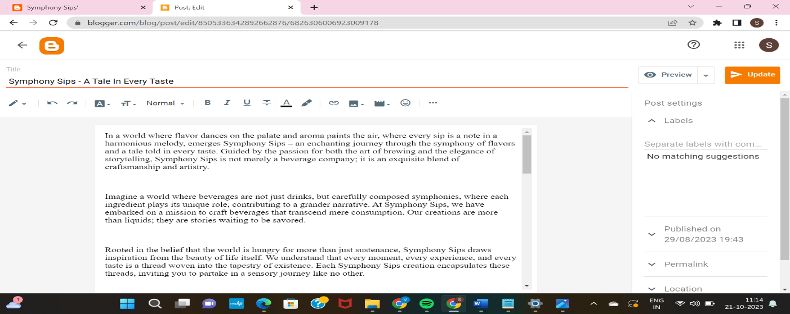

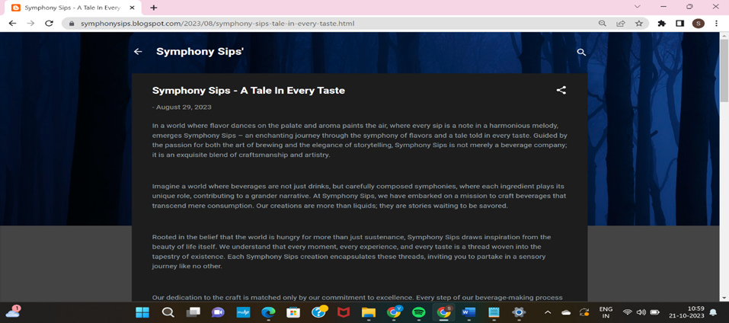

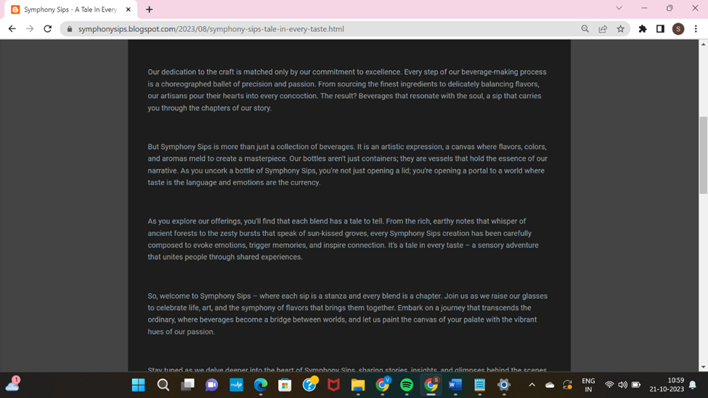

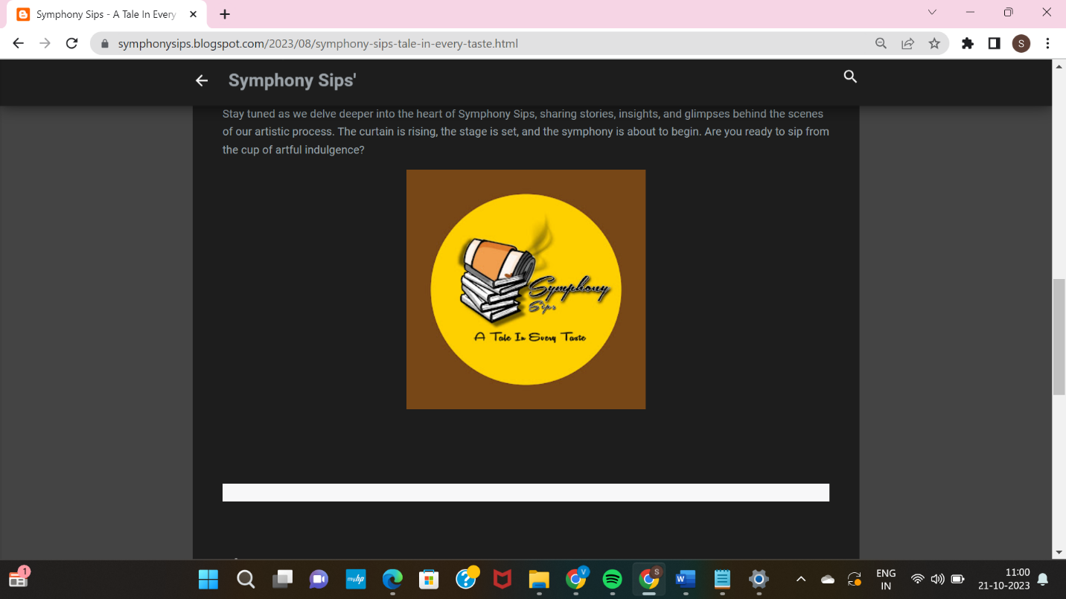

2.Create a New Facebook Business Page and post one social media poster for your brand.

Link: Facebook business page

<https://www.facebook.com/profile.php?id=61550686856357&mibextid=b06tZ0>

Screenshots:

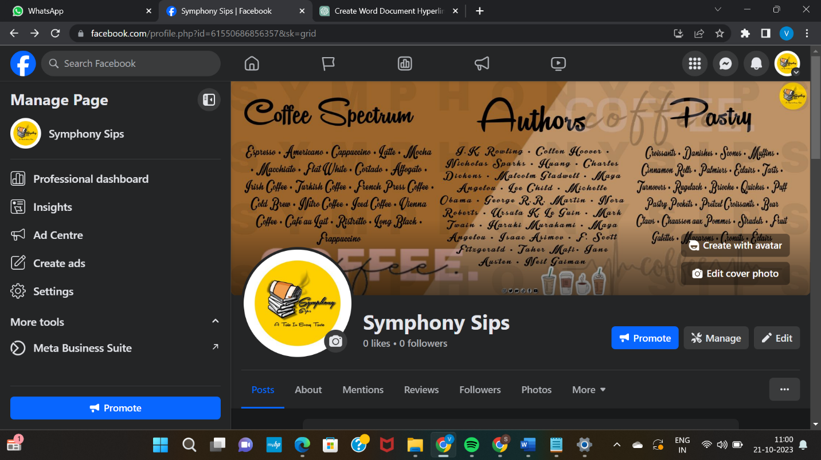

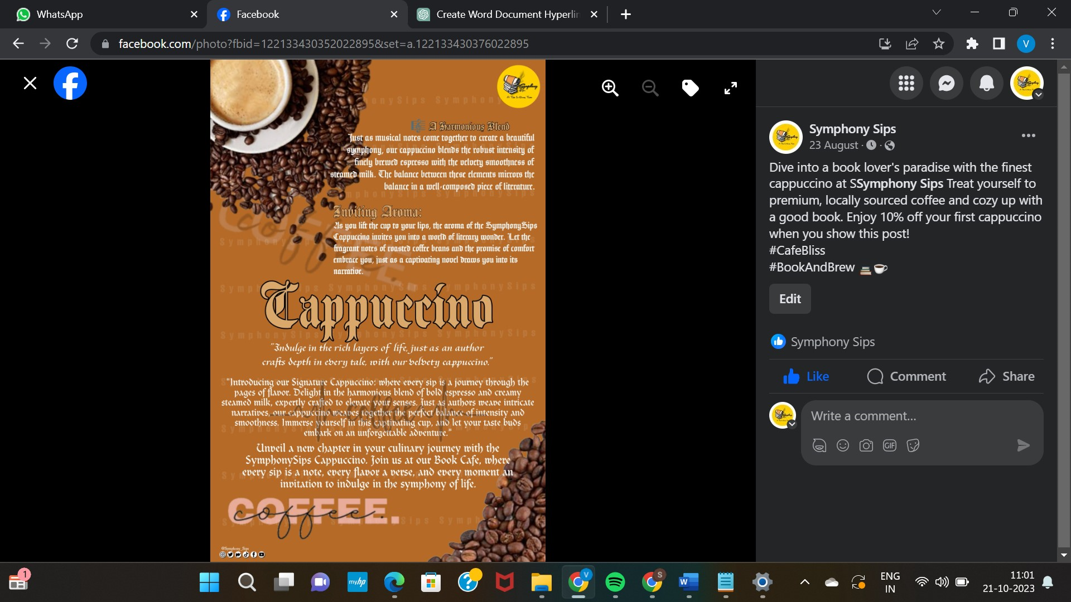

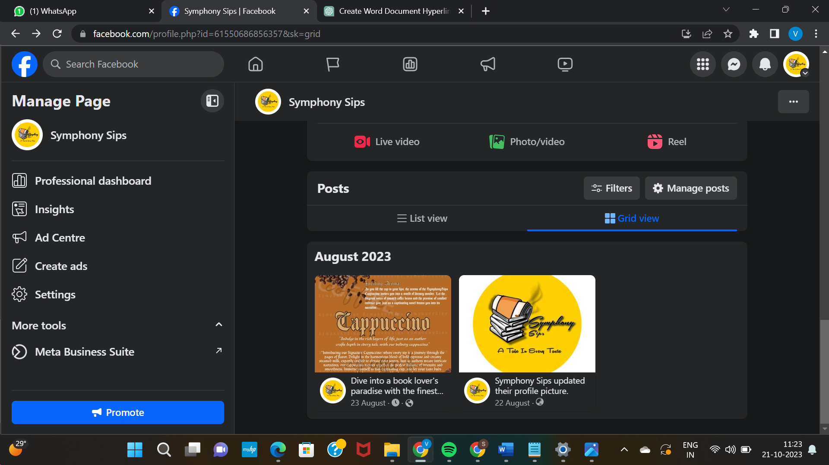

3.Create and design a social media advertisement poster using canva.

Link: Infographics Page Design using canva

<https://symphonysips.blogspot.com/2023/09/journey-through-symphony-sips.html>

Screenshots:

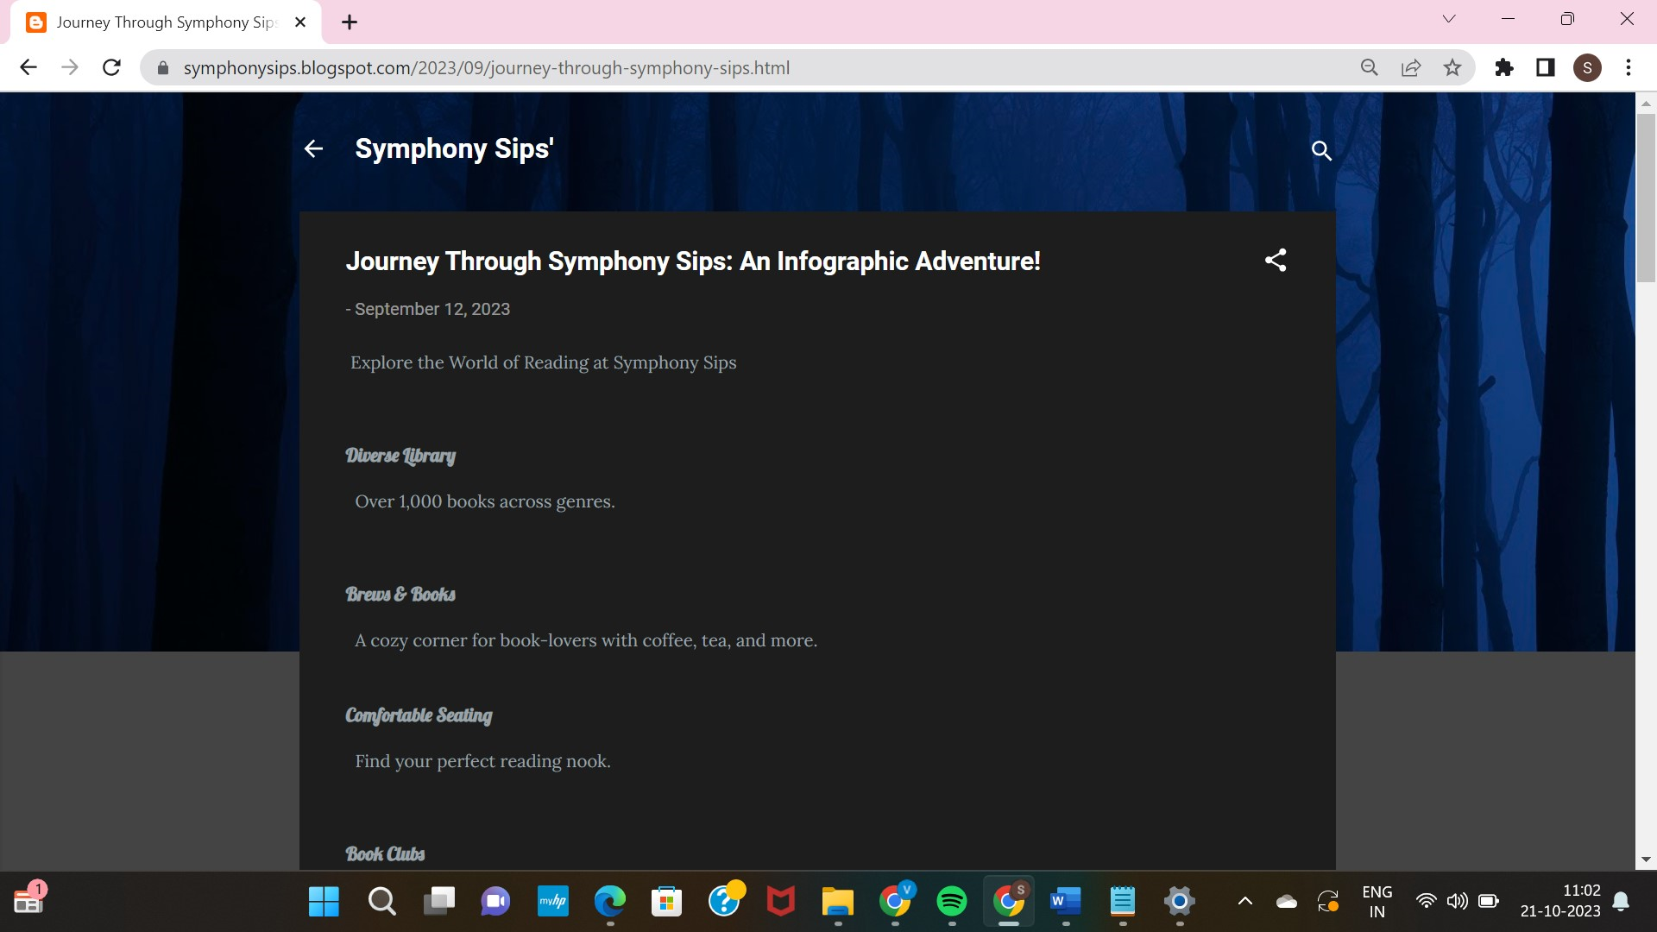

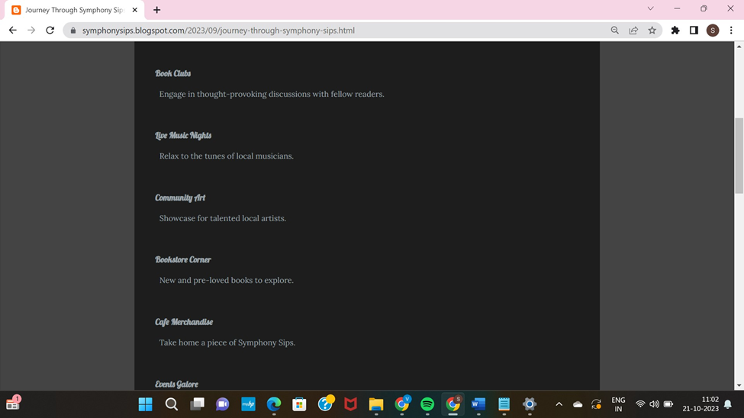

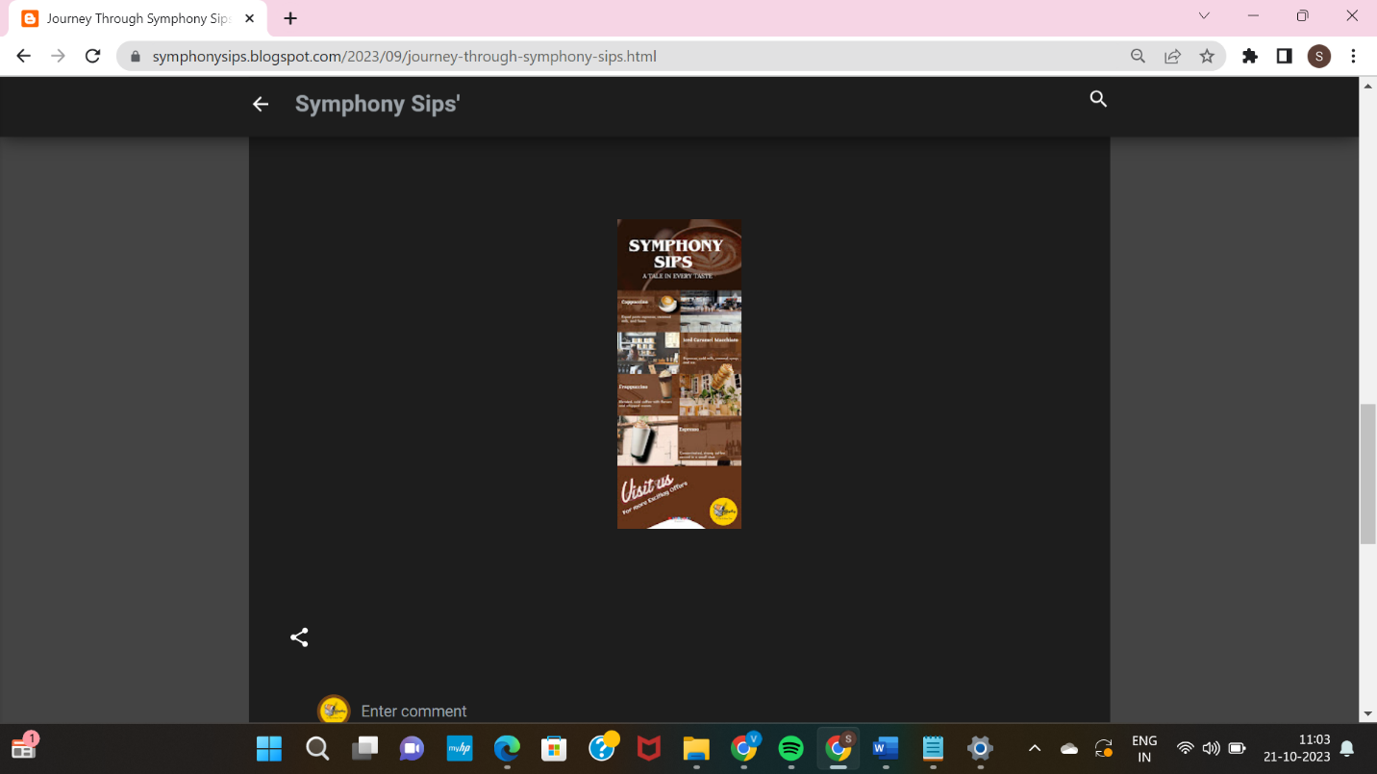

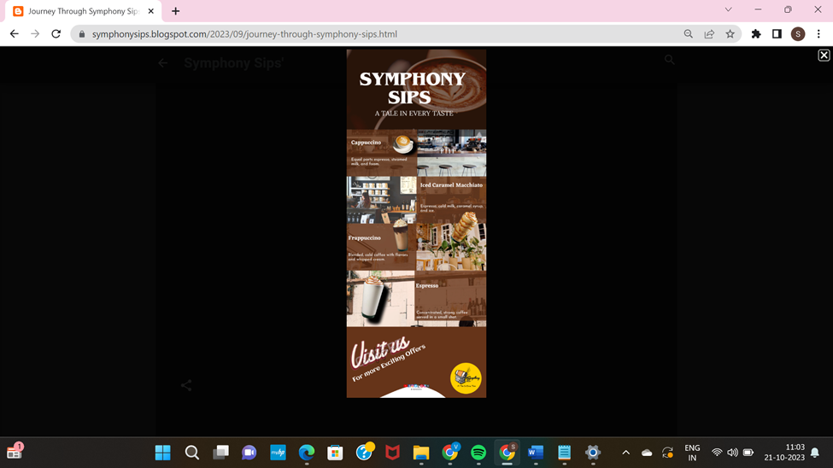

4.Create email newsletter design using MailChimp or canva tool.

Link: Email newsletter design using canva

<https://symphonysips.blogspot.com/2023/09/symphony-sips-email-newsletter.html>

Screenshots:

